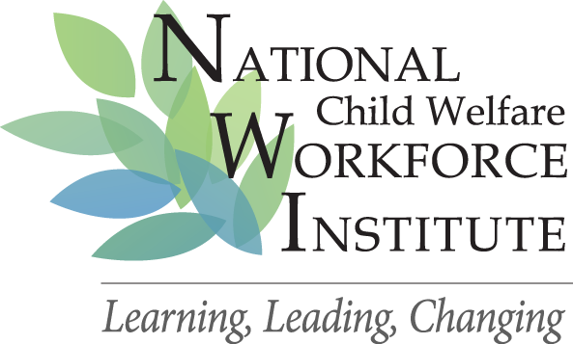

CHILD WELFARE WORKFORCE RECRUITMENT AND RETENTION GRANTEES
CROSS SITE FINDINGS
September 2009

A summary of key findings from Maine, Western Region Recruitment and Retention Grant in Denver, UNC Chapel Hill and New York State recruitment and retention grants:

Supervisors matter and they don’t realize how much influence they have. They have a narrow view of their work, which excludes recruitment and selection and climate building. Teaching recruitment, selection and retention skills to supervisors resulted in higher retention among workers in North Carolina. Mentoring and coaching supervisors in team building activities improved worker retention in New York State.

Data are important for clear identification of issues and challenges, to focus the work to address issues, to track progress

Leaders must pay explicit attention to recruitment, selection and retention of workforce. It helps to have this work included in the mission and values of the agency and in job descriptions for supervisors and managers. WRRR (Denver) found that a strong and productive working relationship with human resources is necessary for implementation and ongoing assessment of selection outcomes and effectiveness.

Agencies that use work groups as teams to address R&R challenges have better outcomes with both.

Design, development and implementation of a competency based approach to recruitment, selection, training and performance evaluations improves the “fit” between new employees and the job and reduces turnover.

Key Principles
Each agency is unique and requires individually developed approaches to R&R work. Having a clear mission and values statement which includes R&R work helps set the stage for work teams, as it provides a focus and commitment from leadership. How this work will roll out is unique to the agency. There is no specific protocol that can be applied across the board. There are general principles that must be attended to:
- Shared Mission & Values
- Design, Development and Implementation of specific competencies for the jobs.
- Recruitment plan that reflects the mission and values and competencies
- Realistic job preview that presents the challenges and rewards of the work to encourage informed decision making on the part of potential applicants.
- Interviewing protocols that explore “fit”
- Training that reinforces the competencies
- Performance evaluations that flow from competencies.
- Data, data, data that are focused on the questions of import and feed the work.
- Worker and supervisor involvement in the work of the agency around problem identification and resolution.
- Across the four studies, findings indicate that agencies that operate on the basis of many of these principles have improved retention. In addition, Maine’s findings show that worker practice is a better fit with the work.

